AES Motion Correction App Manual

# Introduction

The motion correction app can be used to automatically correct for rigid XY motion in the sample during imaging with AES. While processing, it can also collect traces for sample ROIs, collect a total (electrical) background mean/stdev trace, collect an x-y displacement trace, check for sample ROIs drifting outside of the AES activation region, save a time projection of the video, and compress the video by eliminating data from outside the AES excitation region.

The typical approach to motion correction by cross correlation fails with AES because the pattern of exposure generated by AES does not shift with the sample while also dominating the cross correlation. This can be corrected by first tagging the locations where light is exposed, setting the remaining pixels to 0, and subtracting the local mean intensity from each location.

# Mask Types

There are three types of masks that the system uses to process a stack. AES masks correspond to the regions of the frame where the laser is active and which give meaningful structural information. These masks lean towards more restricted regions when boundaries are ambiguous to ensure that the pattern of AES exposure is effectively neutralized before cross correlation. These masks must be included (or autogenerated) to do any motion correction with AES.

Sample masks correspond to spaces on the sample itself that we are trying to track (i.e. neurons). These are needed only for extracting traces from the data while processing. Otherwise, they can be ignored.

The exposure mask is the total area illuminated in the frame. This is essentially the superposition of the AES masks, but it should be expanded more liberally. The area outside the exposure mask is used for background measurement, so a narrower mask increases the risk of including unintended signal in the trace. If background traces are not being taken during processing, this mask can be ignored.

# UI Elements

1. Viewing Window
2. Channel Select Field
3. AES ROI Panel
4. Sample ROI Panel
5. Stack Tab
   1. Load Reference Stack
   2. Bidirectional Shift
   3. Window/Level
   4. Manage Input Videos
   5. Process Video
6. ROI Tab
   1. Load Exposure Mask
   2. Remove Exposure Mask
   3. Load AES ROIs
   4. Load Sample ROIs
   5. Autodetect ROIs
   6. Adjust ROIs

## 1. Viewing Window

The viewing window lets you look at the masks in relation to your reference image before committing to file processing. ROI’s can be selected by clicking on them. Hold control while clicking to highlight multiple masks. Conversely, selecting an ROI in one of the list panels on the side or in the ROI adjustment window will highlight it in the viewing window.

The reference image is shown in gray scale, AES ROIs are shown in yellow, sample ROIs are shown in red, the exposure mask is shown in blue, and highlighted ROIs are shown in green.

## 2. Channel Select Field

The channel select field allows you to swap between channels of the reference stack for multi-color and/or bidirectional videos. For slow axis bidirectional video, the projection of odd frames is shown on round numbers while the projection of even frames is shown on half numbers (i.e. the even frames of channel 2 correspond to 2.5 on the spinner while the odd frames correspond to 2.0). If using different masks for different channels, you must switch to the desired channel before adding/removing/modifying masks. Motion correction will always be done relative to the main channel (and only odd frames if using slow axis bidirectional scanning).

## 3. AES ROI Panel

This panel lists all currently loaded AES ROI masks. New masks can be loaded using the add button. The remove button removes all masks currently selected on the list. The rename button renames the currently selected mask. If multiple masks are selected, the first mask in the list is chosen to rename.

## 4. Sample ROI Panel

This panel lists all currently loaded sample ROI masks. New masks can be loaded using the add button. The remove button removes all masks currently selected on the list. The rename button renames the currently selected mask. If multiple masks are selected, the first mask in the list is chosen to rename.

## 5. Stack Tab

### 5.1 Load Reference Stack

Loading a reference stack stores the filename for processing while also reading in an initial average of frames to view alongside masks in the viewing window. It is set not to read more than 5000 frames for initial viewing.

The “Main Channel” is the primary channel that is used for motion correction.

Setting a “frame limit” to the intended initial window for motion correction can ensure that the position of elements in the reference image you see aligns well with the output video.

The “bidirectional” box tells the software that the image was generated with slow axis bidirectional scanning (assuming that the resulting video has two frames contained in each image of the stack).

“Split Channels” indicates that the different channels are segmented independently and use different masks.

## 5.2 Bidirectional Shift

If slow axis bidirectional scanning is used, a delay between the microscope time software and the scanner will cause odd frames to be shift vertically in one direction and even frames to be shift by the same amount in the opposite direction. When the software understands that bidirectional slow axis scanning was used during acquisition, it automatically calculates and applies the reverse shift using cross correlation of the reference images. If this does not yield satisfactory results, the pixel shift can be adjusted manually from a small window opened with the “bidirectional shift” menu option.

### 5.3 Window/Level

After loading a reference image, you can adjust the window level to see features better. This has no impact on how the program processes the video. Different channels are adjusted independently.

### 5.4 Manage Input Videos

If multiple videos were taken of the same region, with the same AES pattern, you can reuse segmentation of one video across multiple videos. To do this, you must input all target videos prior to processing. 5.4 opens a window where you can manage active videos and select which one is shown in the viewer. The current reference stack will always be at the top of the stack list and cannot be removed. You can select a different stack by selecting a video from the stack list and clicking “set reference”.

### 5.5 Process Video

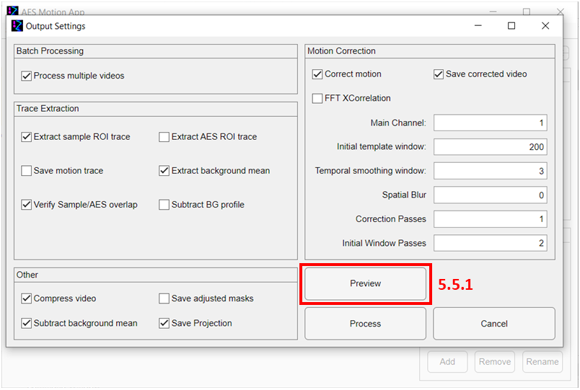

After setting up all ROIs that you intend to use, you can open the output dialog window to configure data extraction and output settings. When describing the file naming, <output> is the primary output directory, <vidname> is the filename of the video, <aes> is the name of the AES ROI, and <smpl> is the name of sample ROI.

**Batch Processing**: These options are only available if multiple videos have been selected. If “Process multiple videos” is unchecked, only the reference stack will be processed.

**Trace Extraction**:

All traces for a given video are saved in the directory <output>/<vidname>/bin. If sample or AES ROI traces are saved alongside other traces, they go in <output>/<vidname>/bin/smpl_roi_traces and <output>/<vidname>bin/aes_roi_traces respectively. If channel splitting is used, trace filenames will be appended with _ch<c>, where <c> is the channel number corresponding to the trace.

1. “Extract sample ROI trace” extracts the pixel data from each sample ROI after motion correction and saves to file as <vidname>_<smpl>. Each column in the output is a pixel while each row is a frame.
2. “Extract AES ROI trace” does the same thing for the AES ROIs prior to motion correction and titles the files <vidname>_<aes>.
3. “Save motion trace” saves the calculated x-y displacement trace as <vidname>_displacement. Column 1 is x pixel displacement, column 2 is y pixel displacement, and each row is a frame.
4. “Extract background mean” extracts the means and standard deviation of all pixels outside of the input masks and saves them as <vidname>_bg_mean. The first column is mean and the second column is standard deviation.
5. “Verify Sample/AES overlap” saves a boolean trace for each sample ROI in <vidname>_in_bounds, which is true if the sample ROI lies fully with an AES ROI and false if it does not. Each column represents a sample ROI. The column associated with each ROI is saved in <vidname>_roi_index.
6. “Subtract BG Profile” calculates the average background row by row for each frame. This is saved in <vidname>_bg_profile, where each column is a row in the image. The profile is subtracted from the image prior to any other trace extraction or averaging.

**Motion Correction**: These tools are only accessible if an AES ROIs are loaded.

1. “Correct motion” corrects for rigid lateral shifts in the image.
2. “Save corrected video” saves a new stack with shifts applied to compensate for motion in <output>/<vidname> as <vidname>_motion_corrected.
3. “FFT XCorrelation” does the cross-correlation calculation used for motion registration in k-space. The speed advantage gained from this depends on the size of the AES ROIs. For cases with many small ROIs, direct x-correlation may be faster. Larger ROIs will benefit from the k-space operations.
4. “Main Channel” defines the channel used for comparisons when doing motion registration.
5. “Initial template window” is the number of frames from the beginning of the stack which are averaged and used for comparison in cross correlations.
6. “Temporal smoothing window” is the number of frames around the current index used to form the comparison to calculate the rigid shift. The window is a gaussian weighted average falling to 1/e^2 at each edge.
7. “Spatial Blur” applies a Gaussian spatial blur to the reference frame and comparison frames generated when doing motion registration. If set to 0, no blur is applied.
8. “Correction Passes” defines the number of motion correction iterations done throughout the video. On additional passes, the displacement from previous iterations is applied before taking the temporal average. For low signal images requiring a large temporal smoothing window with oscillatory window, this may help.
9. “Initial Window Passes” defines the number of motion correction iterations done when generating the initial reference frame.

**Other**:

1. “Compress video” sets all values outside of the input masks to 0 and turns on PackBits compression (lossless for everything within the masks). If the video is not also motion corrected, it will be saved in <output>/<vidname> as <vidname>_compressed.
2. “Save adjusted masks” saves all masks used as tiffs into <output>/masks. This takes into account any auto generated masks or adjustments made in the app to existing masks.
3. “Subtract background mean” subtracts the average background value before saving the video. If “Subtract BG profile” is selected, the row background average is used instead of the total average.
4. “Save Projection” saves a projection of the video (with separate frames for each color channel) in <output>/<vidname> as <vidname>_projection (if motion correction is selected the name changes to <vidname>_motion_corrected_projection).

**Buttons**:

1. “Preview” opens a preview window to see how the motion correction output will look for a small selection of frames under the current setting. (covered in more depth in the below section for 5.5.1)
2. “Process” commits current settings and begins processing videos.
3. “Cancel” exit from window.

### 5.5.1 Preview Window

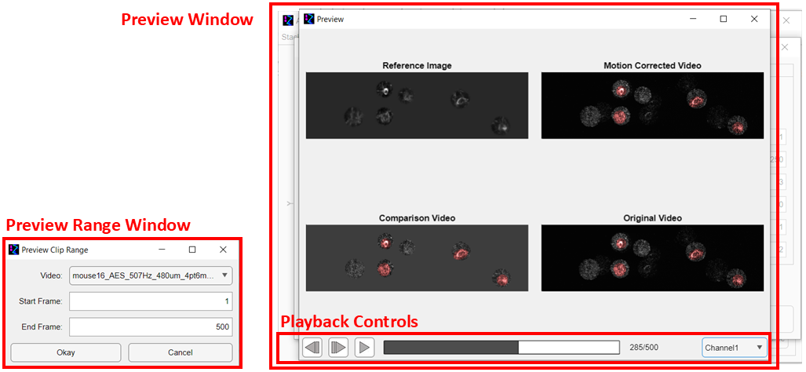

**Preview Range Window**

When “Preview” is selected from the “Process Video” window, another window appears asking for a video (from the list of videos that you have selected for processing) along with a range of frame rates. The frames shown in the subsequent preview window are based on this selection.

**Preview Window**

A selection of frames is generated based on the motion correction settings currently selected. The “Reference Image” is the initial averaged frame generated from the reference stack (regardless of what video is selected). The “Comparison Video” is the frame generated by temporal and spatial smoothing around the current frame in the selected video which is compared against the reference image to calculate displacement. The “Original Video” is the original unedited video (except for intensity normalization and deinterlacing of frames by channel/bidirectionality). The “Motion Corrected Video” is the same as the original video with the reverse displacement applied from motion registration. The red regions are the sample ROI pixels.

**Playback Controls**

Playback controls including play/pause, advance frame, and previous buttons, a scrubber, and a channel selector are available to view the video. The video plays at 30 fps.

## 6. ROI Tab

### 6.1 Load Exposure Mask

Select a tiff to serve as the exposure mask. The image should have the same dimensions as the reference stack with value 1 inside the mask and 0 outside the mask. For slow axis bidirectional data, the mask should be twice the size of the image on the y axis, with only the top half being used for the mask.

### 3.2 Load AES ROIs

This is the same as clicking the “add” button in the AES ROI Panel. Similar to the exposure mask, each AES mask should be a separate Tiff file with the same dimensions as the reference stack having value 1 within the mask and outside.

### 3.3 Load Sample ROIs

This is the same as 3.2 but for the sample masks.

### 3.4 Autodetect ROIs

A window opens to select thresholds for generation of the AES and exposure masks. Disabling either of the sliders will disable the generation of the respective masks. For the exposure mask, all pixels below the selected value (shown in green) are selected as the mask. For the AES masks, all pixels below the selected value (shown in red) are segmented with a blob detection algorithm into separate masks.

### 3.5 Adjust ROIs

An adjustment window can be used to fine tune existing masks. You can either laterally shift them or change the margin to expand/contract the masks. Individual masks can be selected by either clicking them in the viewing window or selecting the name from the drop-down menu. The drop-down menu also allows you to select the exposure mask, or simultaneously select all AES/Sample masks. “Cancel” reverts all masks to before the window was opened while “apply” commits the changes.

# Other things

All the traces are saved as .bin files. Their structure is described in aes_file_format.txt. They can be opened with the AESFile class or read using the included static methods.